11.7 Titration
Name: ____________________ Class: ____________________ Due date:
1. Which salt preparation uses a burette and a pipette? （ ）
A calcium nitrate from calcium carbonate and nitric acid
B copper(II) sulfate from copper(II) hydroxide and sulfuric acid
C potassium chloride from potassium hydroxide and hydrochloric acid
D zinc chloride from zinc and hydrochloric acid

2. Crystals of sodium chloride were prepared by the following method.
$25.0cm^{3}$1 of dilute hydrochloric acid was accurately measured into a conical flask.
2 Aqueous sodium hydroxide was added until the solution was neutral. The volume of sodium hydroxide added was measured.
$15cm^{3}$3 Solution was evaporated and crystals washed with approximately of water.
$25.0cm^{3}$Which row shows the pieces of apparatus used to measure the of HCl,
$15cm^{3}$the volume of aqueous sodium hydroxide and the of water? （ ）
 | 25.0cm³ of hydrochloric acid accurately | the volume of aqueous sodium hydroxide added | 15cm³ of water approximately
A | burette | pipette | measuring cylinder
B | measuring cylinder | burette | pipette
C | pipette | burette | measuring cylinder
D | pipette | measuring cylinder | burette

3. Which salt preparation uses a burette and a pipette? （ ）
A calcium nitrate from calcium carbonate and nitric acid
B copper(II) sulfate from copper(II) hydroxide and sulfuric acid
C potassium chloride from potassium hydroxide and hydrochloric acid
D zinc chloride from zinc and hydrochloric acid
4. The four pieces of apparatus shown below are used in chemical experiments.
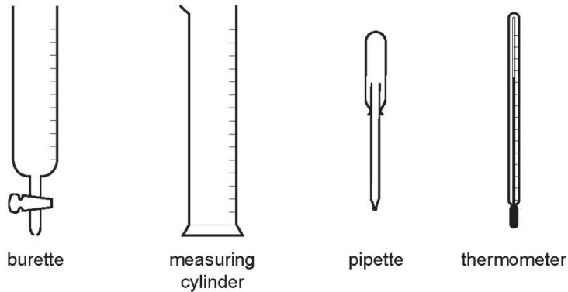
Which statement about the apparatus is correct? （ ）
A The burette measures the volume of liquid added in a titration.
B The measuring cylinder measures the mass of a substance used in an experiment.
C The pipette measures the volume of gas given off in a reaction.
D The thermometer measures the density of a solution.
4. Three ways of making salts are
titration using a soluble base or carbonate
neutralisation using an insoluble base or carbonate
precipitation.
Complete the following table of salt preparations.
method | reagent 1 | reagent 2 | salt
titration |  |  | sodium nitrate
neutralisation | nitric acid |  | copper(II) nitrate
precipitation |  |  | silver(I) chloride
neutralisation | sulfuric acid | zinc(II) carbonate
Write an ionic equation with state symbols for the preparation of silver(I) chloride.
..................................................................................................................................[2]
Complete the following equation.
$$ZnCO_{3}+H_{2}SO_{4}→…………………………………………………………………………………………$$
The hydroxides of the Group I metals are soluble in water. Most other metal hydroxides are insoluble in water.
Crystals of lithium chloride can be prepared from lithium hydroxide by titration.
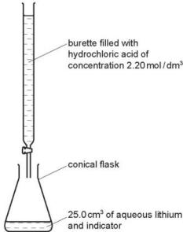
$25.0cm^{3}$ of aqueous lithium hydroxide is pipetted into the conical flask. A few drops of an indicator are added. Dilute hydrochloric acid is added slowly to the alkali until the indicator just changes colour. The volume of acid needed to neutralise the lithium hydroxide is noted.
A neutral solution of lithium chloride, which still contains the indicator, is left.
Describe how you could obtain a neutral solution of lithium chloride which does not contain an indicator.
..................................................................................................................................
..................................................................................................................................

You cannot prepare a neutral solution of magnesium chloride by the same method. Describe how you could prepare a neutral solution of magnesium chloride.
..................................................................................................................................
..................................................................................................................................

4. A student did a single titration to find the concentration of a solution of dilute H₂SO₄.
The student added 25.0 cm3 of aqueous sodium hydroxide to a conical flask, followed by a fewdrops of indicator. Dilute sulfuric acid was then added to the aqueous sodium hydroxide until thesolution was neutral.
The apparatus used is shown in the diagram.
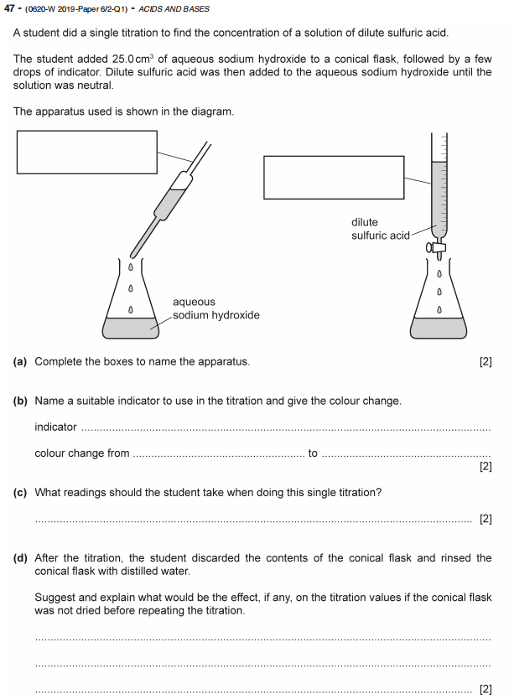

5.
